*SOFTWARE DESIGN SPECIFICATION*

1. **Introduction**

An ATS-Applicant Tracking System is a software application that enables the handling of the hiring and recruitment processes and needs. An ATS can be implemented or accessed online at the enterprise- or small-business level, depending on the needs of the organization.

A dedicated ATS is not uncommon for recruitment-specific needs. On the enterprise level, it may be offered as a module or functional addition to a [human resources](https://en.wikipedia.org/wiki/Human_resources) suite or human resource information system (HRIS). The ATS is expanding into [small and medium enterprises](https://en.wikipedia.org/wiki/Small_and_medium_enterprises) through [open-source](https://en.wikipedia.org/wiki/Open-source_software) or [software-as-a-service](https://en.wikipedia.org/wiki/Software_as_a_service) offerings (SaaS).

* 1. Goals and Objectives

The principal goal of our ATS is to provide a central location and database for a company’s recruitment process with the objective of better assisting the management of resumes and applicant information. Data is collected from internal applications via the ATS front-end, located on the company website, or extracted from applicants on job boards. Most jobs and resume boards have partnerships with ATS software providers to provide parsing support and east data migration from one system to another.

* 1. Statement of Scope

An [applicant tracking system (ATS)](https://www.jobvite.com/products/applicant-tracking-system/) helps companies organize and track candidates for hiring and recruitment purposes. These systems allow businesses to collect information, organize prospects based on experience and skill set, and filter applicants.

[More than 90% of Fortune 500 Companies](https://medium.com/swlh/90-of-fortune-500-companies-use-an-applicant-tracking-system-whats-it-5a6b6d25e5e7) are currently using an ATS. While these systems are excellent for storing candidate information, the best applicant-tracking systems can track all communications with candidates. This makes it easy to search and filter resumes and other candidate information, decreasing time-to-fill and ensuring that companies get the best candidates for the position.

In contemporary times, where thousands of resumes are screened on a daily basis in order to hire the best talent, it becomes very difficult to manage, organize and maintain the workflow effectively and efficiently, so in this case, an Applicant Tracking System plays a major role.

* 1. Software Context

Candidates are looking for application processes that are easy, fast, and user-friendly and they apply to some job sites, and we use that resumes in order to meet the needs of the organization. This means that companies benefit from a larger pool of applicants, which can then be ranked automatically based on skills and experience.

During the recruitment process, applicant tracking systems allow recruiters to review and screen a candidate easily.

* 1. Major Constraints

Our ATS is available on the internet and can be accessed anywhere with a good internet speed. Though it is a Human Resource specified software it may contain some technical terms and jargon that can only be understood by recruiters and human resource professionals.

**2.0 Data Model and Description**

2.1 Data Structures

321.1 Data Objects

We are majorly using Character and Integer data types in order to perform and store all the data that are essential. Character data type is used to store all inputs that are in string format like Names, Published Site names. Integer data types are made in order to record numerical values like phone numbers. Apart from this, we have used the DateTime object to store all the data that require date formats like job posted date and many more.

3.1.2 Relationships

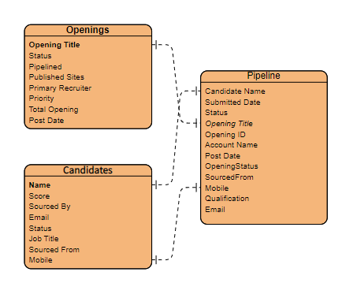

**3.0 Architecture**

3.1 Diagram

We are using Django framework combined with HTML and CSS for frontend and Django admin for storing the data and other functions in the backend.

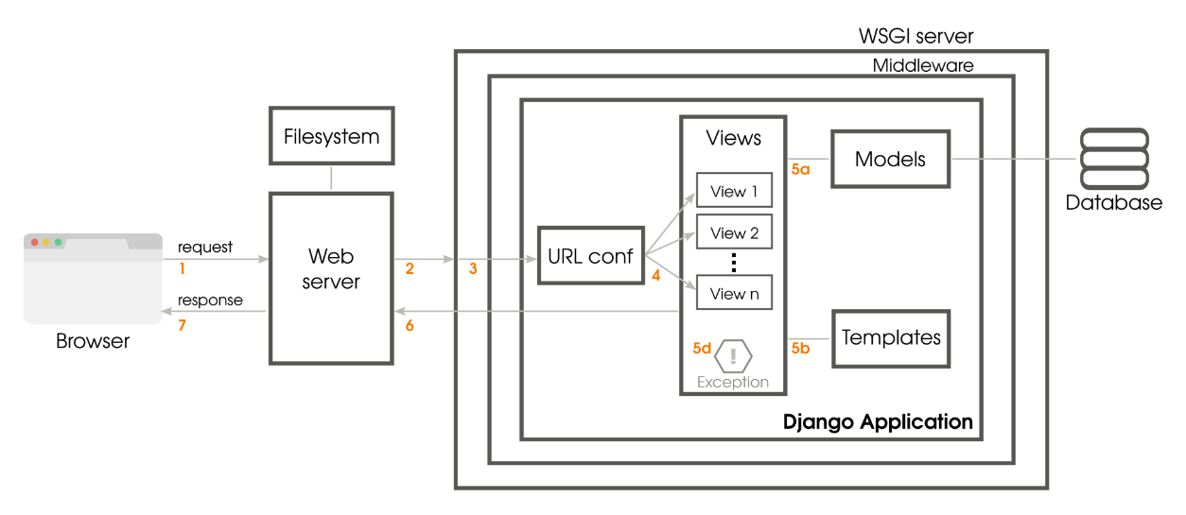

Django Application

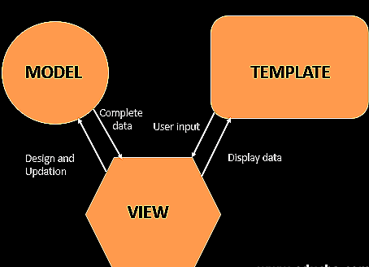

MVT Structure Architecture

Model-Is acts as the interface of our data in from the backend to the frontend and is responsible for maintain data.

View-View include the user interface, what we see in the browser when we click something, it includes HTML, CSS files.

Template-A template consists of static parts of the desired HTML output.

3.2 Description for Components

3.2.1 Login

3.2.1.1 Interface Description

This page include a form in which user id and password in entered by the user for the authentication.

If the user is authenticated, it is then taken to dashboard of our software.

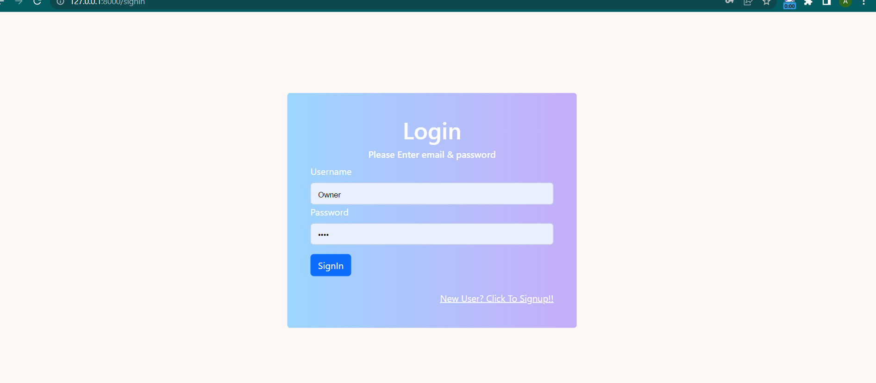

3.2.1.2 Register

Form is present in which all the needed information required for a new user to register is present.

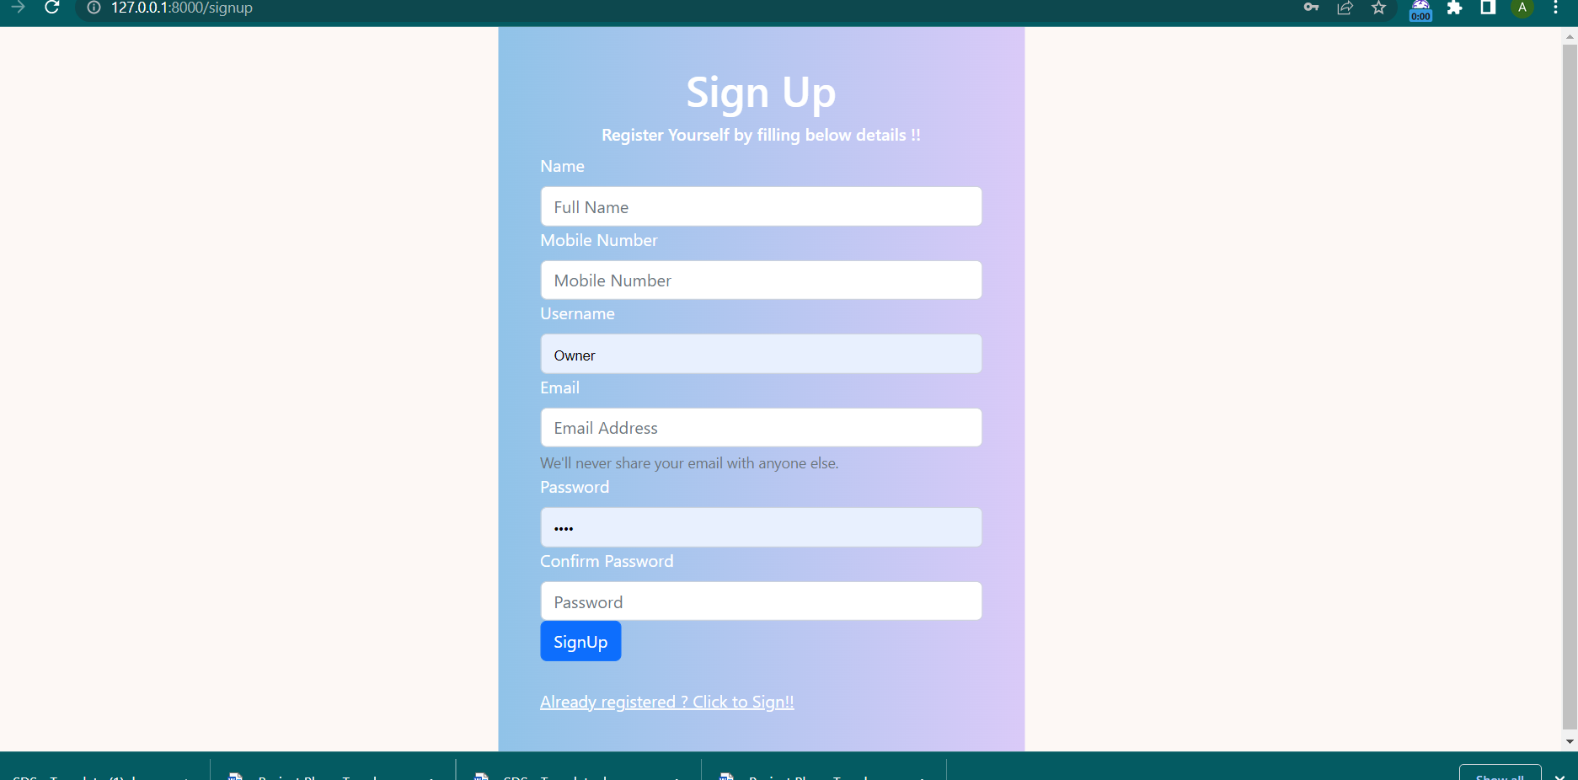

3.2.1.3 Dashboard

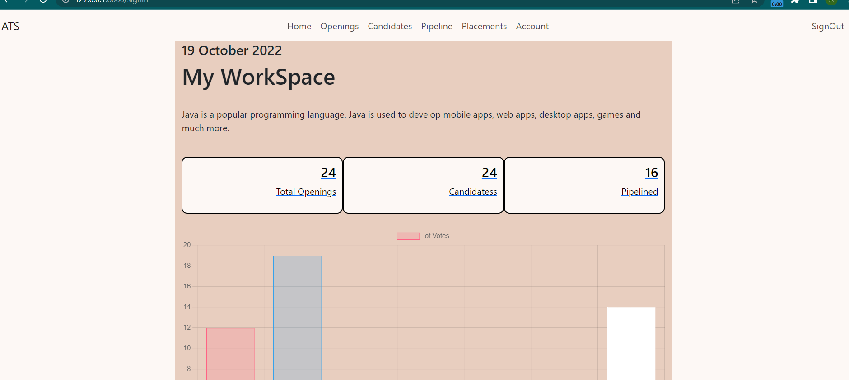

3.2.1.4 Openings

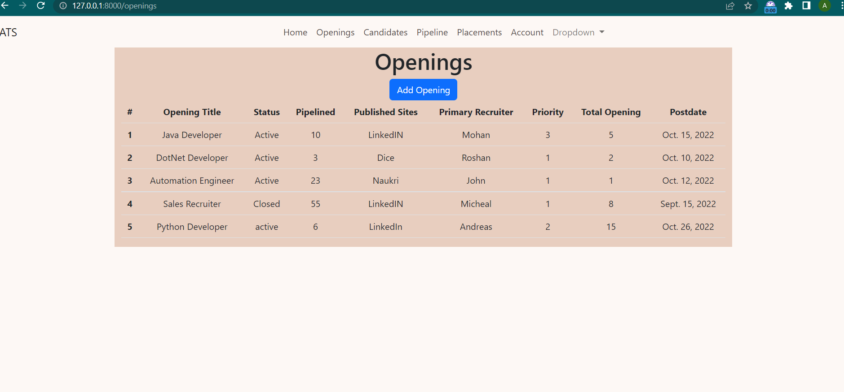

3.2.1.5 Candidates

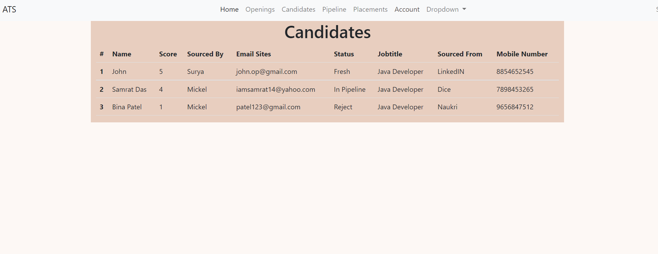

3.2.1.6 Pipeline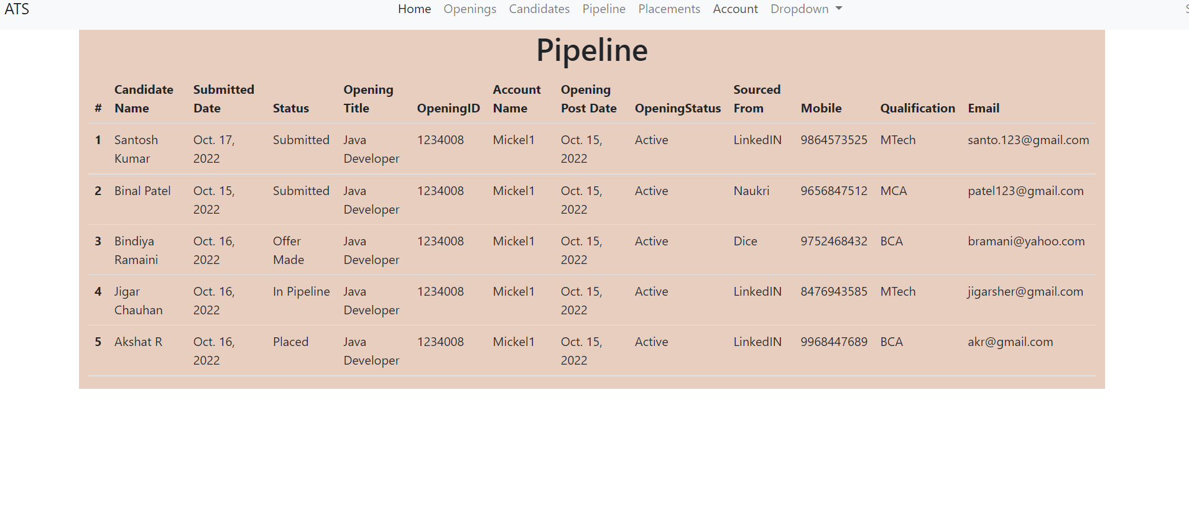

3.2.1.7 Placements

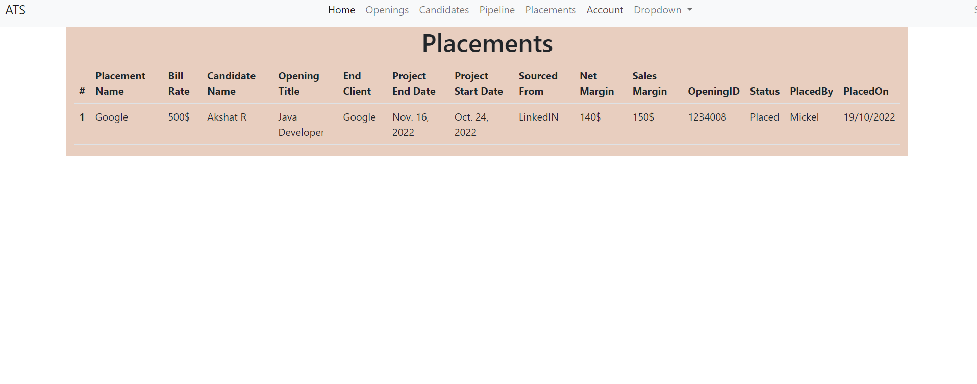

3.3 External Interface Description

Browser-Web browser with an seamless internet connection is required, works with every browser.

**4.0 User Interface Design**

4.1 Description of User Interface

As this is business used app we have kept the UI simple and clean with all the major functionalities for an efficient human resource operations. We have used a light colour combination to for the layout of the pages with the navigation bar on the top with all the information.

**5.0 Restrictions, limitations, and constraints**

As our software deals with the day-to-day functions of Human Resources and management, so we have gone through all the modules and lifecycle of the hiring process and how the data is utilized and managed and developed each and every module keeping in mind to make it effective and efficient.